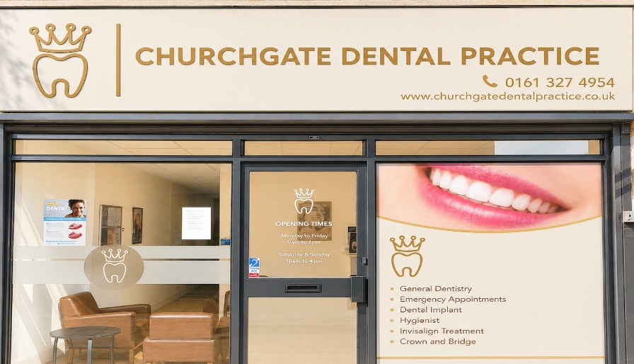
Compliments and suggestions
At Churchgate Dental Practice we aim to give our patients the best possible service – and we’re always happy to hear compliments. If you’d like to show your appreciation to the team, please give us your compliments below.

We’re also keen to hear your suggestions about how we can improve our services – and you can use the form for this too.
Please email this form to Feedback@churchgatedentalpractice.co.uk – Any feedback will be discussed between Sandra Adeeb – Practice Director and James Judge - Practice Manager.
Paper copies of this form are available in Reception.

Full Name

Address

City
Postal
Country
Contact number *
Email address

Feedback

